**SDA**

**Assignment #05**



**Instructor**

Zeeshan Ramzan

**Submitted by**

Abdul Haseeb Siddiqui

2021-SE-22

**Department of Computer Science,**

University of Engineering and Technology, Lahore, New-Campus.

3rd March 2023

**Package Diagram**

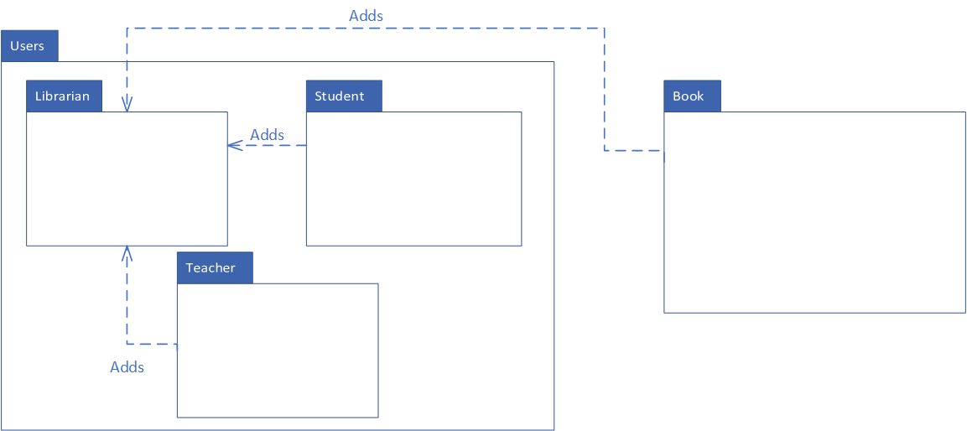

**Component Diagram**

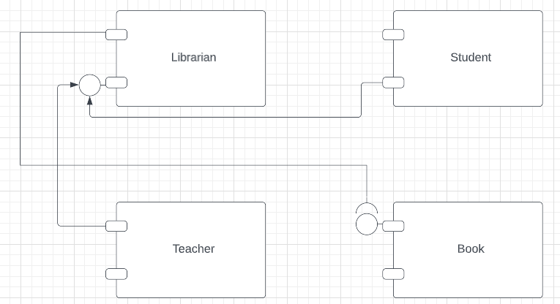

*Dotted arrow was not found*

**Deployment Diagram**

